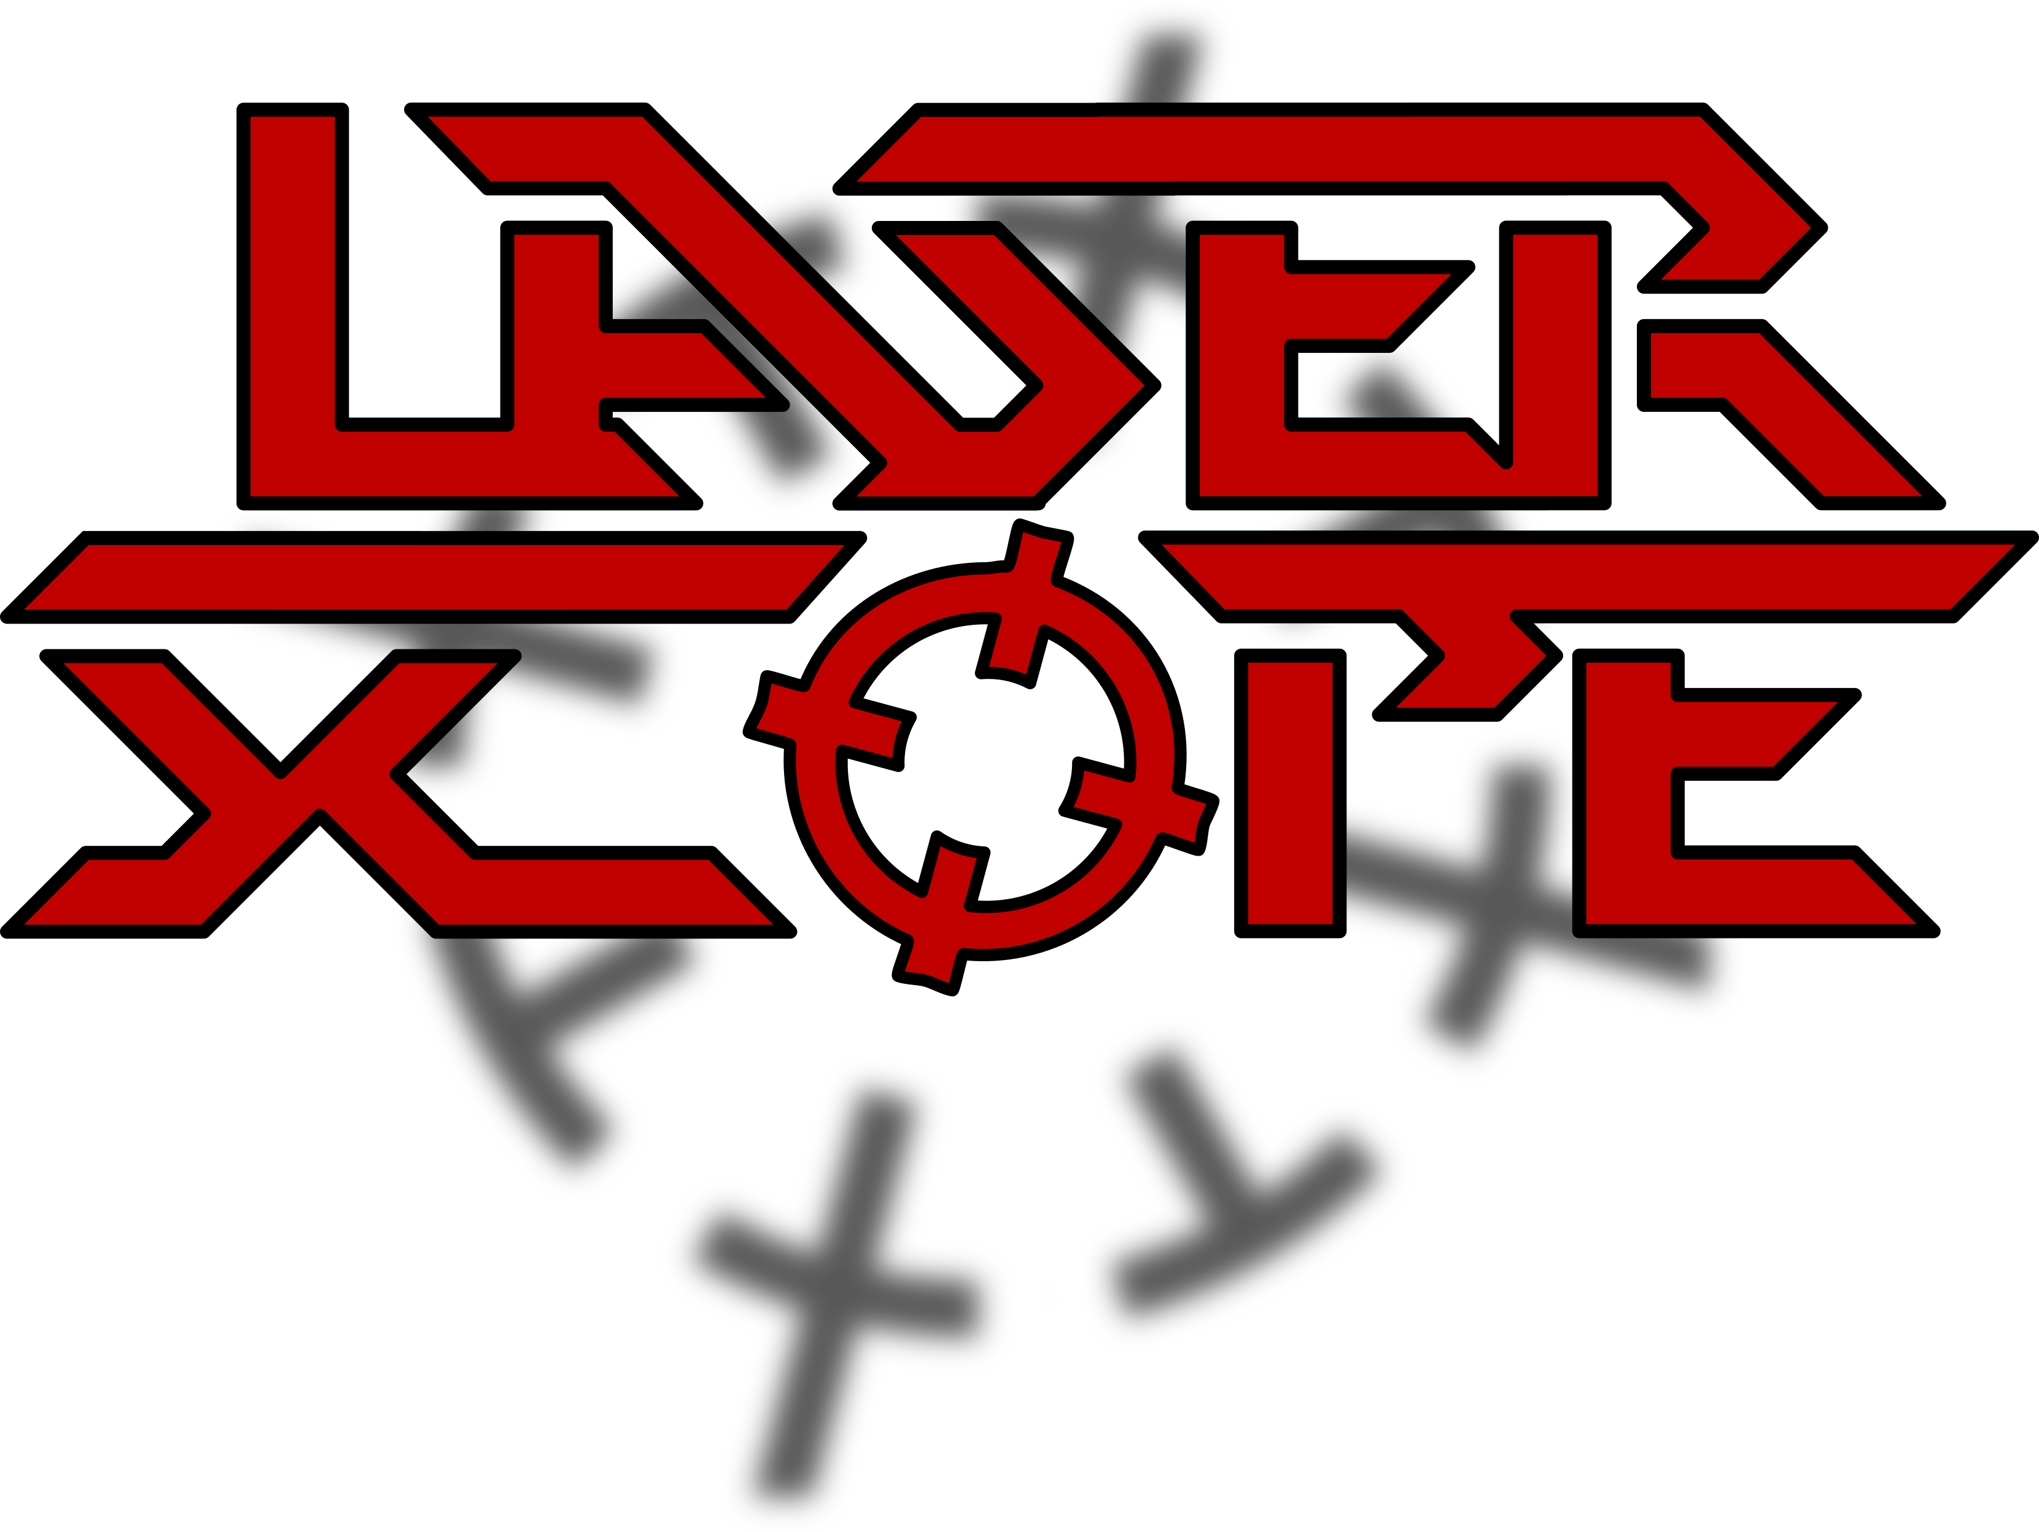
Band biography
Around 2021, Thomas (drums), Christian (bass) and Moritz (guitar) started rehearsing and writing songs together. The line-up was completed with Jens (guitar) at the end of 2021 and Max (vocals) at the beginning of 2022 - LASER SCOPE was born. Over the course of the year, more songs were written and EP recordings began in the summer of 2023, followed by the first gig in 2024.

Contact details:
- E-Mail: kontakt@laser-scope.de
- Tel.: +49 160 92307857 (Thomas Meier)
- Homepage: www.laser-scope.de
- Instagram: https://www.instagram.com/laserscopeofficial
- Facebook: http://facebook.com/laserscopeofficial
- YouTube: https://www.youtube.com/@laserscopeofficial

All images, texts and videos contained in this Electronic Press Kit may be used free of charge by the press and contractual partners of Laser Scope for reporting and advertising purposes.

